EXPERIMENT 7:
INPUT:
#include <iostream>
OUTPUT: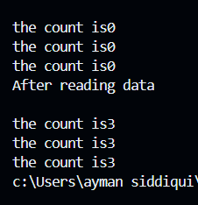
using namespace std;
class item
{
int number;
static int count;
public:
void data(int n){
number=n;
count++; }
void counts(){
cout<<"\nthe count is"<<count;}
};
int item::count;
int main()
{
item t1,t2,t3;
t1.counts();
t2.counts();
t3.counts();
t1.data(10);
t2.data(20);
t3.data(30);
cout<<"\nAfter reading data"<<endl;
t1.counts();
t2.counts();
t3.counts();
return 0;
}
EXPERIMENT 7:
INPUT:
OUTPUT: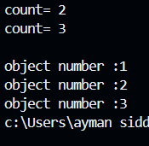
#include <iostream>
using namespace std;
class test
{ int code;
static int count;
public:
void setcode(){
code= ++count; }
void showcode(){
cout<<"\nobject number :"<<code;}
static void showcount(){
cout<<"count= "<<count<<endl;
}
};
int test::count=0;
int main()
{
test t1,t2,t3;
t1.setcode();
t2.setcode();
test::showcount();
t3.setcode();
test::showcount();
t1.showcode();
t2.showcode();
t3.showcode();

return 0;
}

